- Biology is a __________________ science.

  - What does this mean?

- How does the bombardier beetle use chemistry to defend itself?

- Organisms are composed of ________________.

- Define matter –

  - All matter is made of _______________.

- Define element –

- Define compound –

  - Sodium is a ( element or compound )

    - Give two properties of sodium:

  - Chlorine is a ( element or compound )

    - Give two properties of chlorine:

  - Sodium chloride is a ( element or compound )

    - Give two properties of sodium chloride:

- The four elements that make up 96% of living matter are:

- Most of the other 4% of living matter is what elements:

- Which element makes up most of the human body?

- What effects can a nitrogen deficiency have?

- What effects can an iodine deficiency have?

- How many atoms would make a 1 centimeter row?

- Label the nucleus, protons, electrons, and neutrons of this atom:

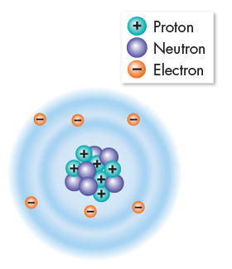

- Protons and neutrons have the same ________________.

- What charge do protons have?

- What charge do neutrons have?

- Protons and neutrons bind together to form the ______________.

- What charge does an electron have?

- How big is an electron?

- Electrons are in ___________________ surrounding the nucleus.

- Atoms have ____________ numbers of protons and neutrons.

  - This makes atoms ___________________.

- How many protons does the carbon atom have?

- How many neutrons does the carbon atom have?

- How many electrons does the carbon atom have?

- Define atomic number –

- Define mass number –

- Define ions –

- Where are each of these ions found?

  - Na+

  - K+

  - Ca+

- Atoms of an element always have the same number of _________________.

- Define isotopes –

- Most isotopes are _______________ but some are _________________.

  - What does it mean to be radioactive?

- Give three applications for radioactive isotopes:

Carbon-14 Dating

- Carbon-14 has a half-life of ____________________.

  - Every time a half life passes, what happens?

- Example: If a 100g organism dies, how much C-14 would be left after…

  - 5,700 years?

  - 11,400 years?

  - 17,100 years?

- When the Shroud of Turin was carbon-14 dated, three steps were taken to make sure the results were not biased. Explain them:

- What date of the Shroud was calculated?

Covalent Bonds

- Elements can combine to form _______________.

  - They are held together with ____________________.

- Define covalent bond –

- Define ionic bond –

- There are three types of covalent bonds:

  - Single Bond –

  - Double Bond –

  - Triple Bond –

- Fill out the chart below:

Name of Compound | Electron Diagram | Structural Formula | Space Model

Energy in Covalent Bonds

- Define energy –

- Define potential energy –

  - Location potential energy –

  - Structural potential energy –

Ionic Bonds

- An ionic bond involves ______________________________________________________.

  - Define ion –

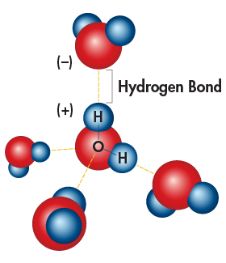
  - Ions with _____________________ charges

______________ each other.

- When does a hydrogen bond occur?

- All of the unusual properties of ________________ are

caused by hydrogen bonding.

- Define cohesion –

- Give two affects caused by cohesion:

- Define adhesion –

- Give one example of how adhesion is used:

- Define heat capacity –

  - Which is colder in the summer? ( Lake Michigan / Chicago )

  - Which is colder in the winter? ( Lake Michigan / Chicago )

- Water is considered a ___________ molecule.

  - What does this mean?

  - Which end has a negative charge?

  - Which end has a positive charge?

- Water is known as the universal _______________.

  - Water can dissolve many _______________.

  - This creates a __________________.

Acids, Bases, and pH

- A few water molecules split into _________________.

- Write the chemical equation of water splitting below:

- Neutral means that ________________________________.

- Acids have ______________________________________.

- Bases have ______________________________________.

- Give three examples of common acids:

- Give two examples of common bases:

- pH measures _________________________________________________________.

  - Solutions with a pH below 7 are ____________________.

  - Solutions with a pH above 7 are ____________________.

  - Solutions with a pH of exactly 7 are ___________________.

- What is the homeostasis pH level of blood?

  - What pH does sweat have and why?

  - What pH does saliva have and why?

- Define buffers –

- Why are buffers important for life?

Other Chemical Bonds

- Define Van der Waals interactions –

  - Give an example:

- Rank the chemical bonds from strongest to weakest:

