- What is the plasma membrane?

- The plasma membrane exhibits ________________________.

  - What does this mean?

- The plasma membrane is made of ______________________.

  - Phospholipids contain both __________________________ and

____________________________ regions.

- What does the fluid mosaic model state?

- Sketch the phospholipid bilayer of a cell:

- Sketch the phospholipid bilayer with proteins:

- What happens to a membrane when temperatures cool?

- What state must membranes be in to work properly?

  - Membranes are about as fluid as ____________________.

  - Membranes are fluid because they contain ________________________________.

- What is the purpose of cholesterol in cell membranes?

  - What does cholesterol do at warm temperatures?

  - What does cholesterol do at cool temperatures?

- What determines most of the specific functions of a membrane?

- Define peripheral proteins –

- Define integral proteins –

- List the six major functions of membrane proteins:

- Cells can recognize each other by:

  - This is how the immune system recognizes _______________________________.

- The cell membrane is __________________________.

- Nonpolar molecules can pass through the membrane (easily / slowly )

  - Examples:

- Polar molecules can pass through the membrane (easily / slowly )

  - Examples:

- Why are transport proteins needed in cells?

- What do channel proteins do?

  - What is aquaporin?

- What do carrier proteins do?

Types of Cell Transport

- Define diffusion –

- Diffusion is considered passive transport. What does this mean?

- Label the diagram below:

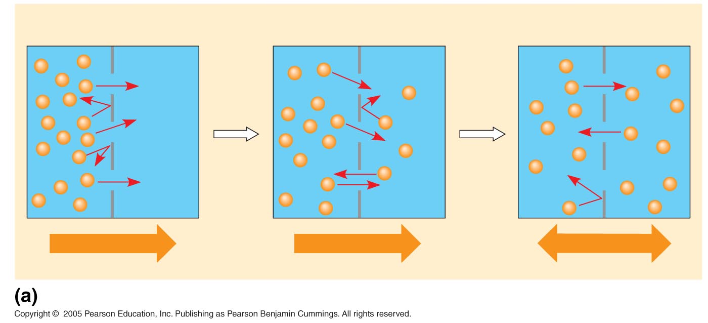

- Define osmosis –

- The direction of osmosis is determined by ____________________________________

______________________________________________________________________.

  - Define solutes -

- Water diffuses across a cell membrane from a region of ____________________________ to

a region of ________________________________.

- Label the diagram below:
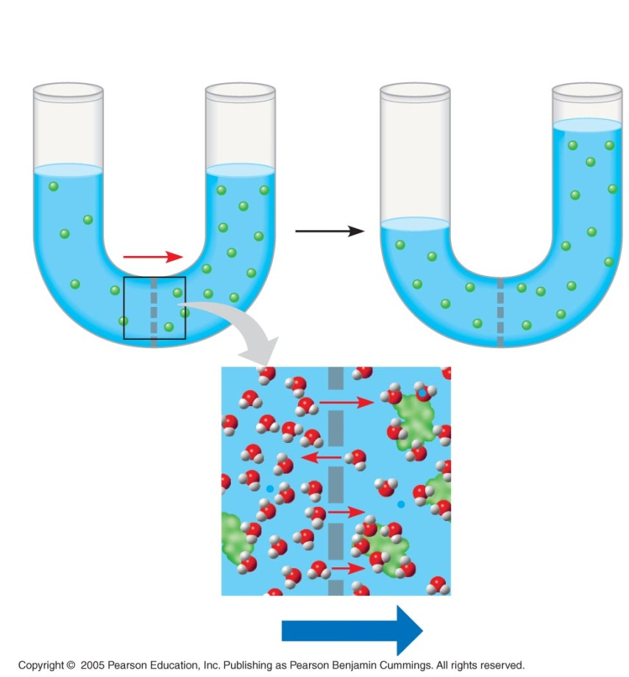

- Define isotonic solution –

  - What happens to a cell in this situation?

- Define hypertonic solution –

  - What happens to a cell in this situation?

- Define hypotonic solution –

  - What happens to a cell in this situation?

- What does the red blood cell look like in an isotonic environment?

- What does the red blood cell look like in distilled water?

- What does the red blood cell look like in salt water?

- Why can’t animals cannot survive in hypertonic or hypotonic environments?

- Give an example of an organism that has adapted to survive in a different environment:

- Plant cells have ___________________.

- Cell walls are _________________ than plasma membranes and do not _______________.

- What does the red blood cell look like in an isotonic environment?

- What does the red blood cell look like in distilled water?

- What does the red blood cell look like in salt water?

- Define facilitated diffusion -

  - This increases the _______________ of transport.

  - This is considered: ( active / passive ) transport.

- What does active transport do?

  - Active transport requires _____________________.

  - What is ATP?

  - Active transport is performed by _________________________ in the membranes.

- What is exocytosis?

- What is endocytosis?

- Define the three types of endocytosis:

  - Phagocytosis:

  - Pinocytosis:

  - Receptor-mediated endocytosis: ______________ each other.

